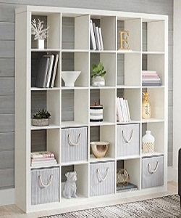

Divider

$130.71

Availability: In stock

Description:

Beautiful and 'The brilliant White color' for its vivid presentation in which the landscape is in perspective, with 5 drawers in each row 5 colomns.It is cubic shape divider. Assembly is required. this room divider can be used to define space in an open concept room, or can be set in front of a large window for privacy. Rounding out the design, metal hinges make folding and storage a breeze when not in use.